

SYMBIOSIS INTERNATIONAL (DEEMED UNIVERSITY)
(Established under section 3 of the UGC Act 1956)
Re-accredited by NAAC with “A” Grade

Name of the Student: Sneha Sah PRN: 25070122189
Semester: 3 Year: AY 25-29

ASSIGNMENT No: 11

TITLE: Write a Java program to demonstrate the implementation of interfaces.
Problem Statement: Write a Java program to demonstrate the implementation of interfaces.
Theory:
An interface specifies a set of abstract methods that implementing classes must define. It provides complete abstraction and supports multiple inheritance of type. Interfaces improve modularity, loose coupling, and software flexibility. They allow different classes to implement common behavior while maintaining independent implementations. Interfaces are widely used in enterprise application development.

Exercise 1.

Create an interface Printable and implement it in Student and Employee classes.

Source code:

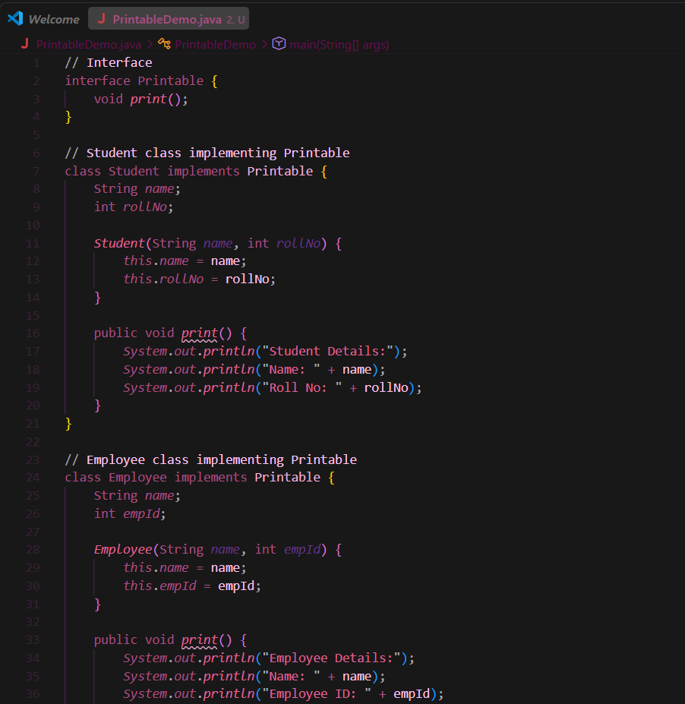
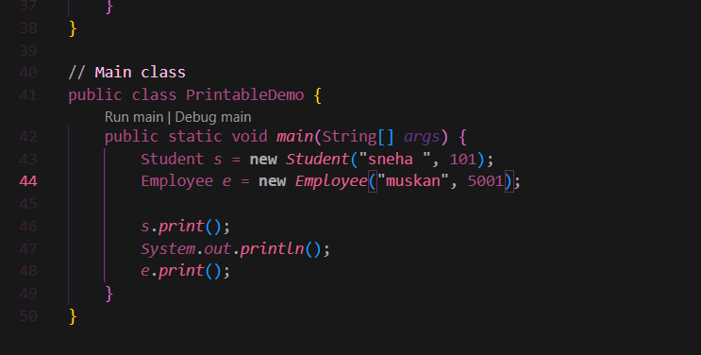

Output:
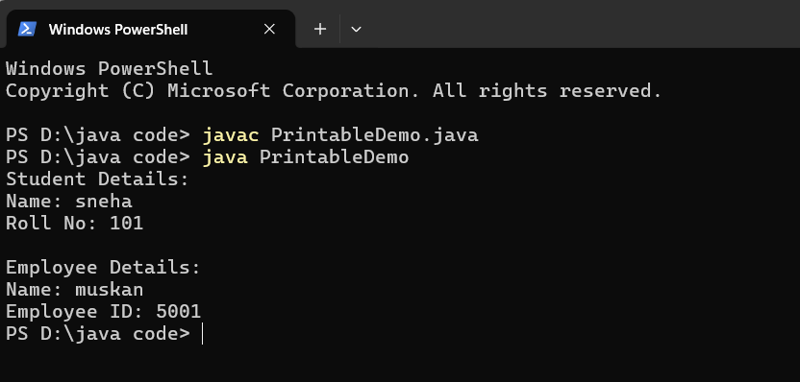

2. Create an interface Switchable with a method turnOn(). Implement the interface in Light and Fan classes to display the device status.

Source code:

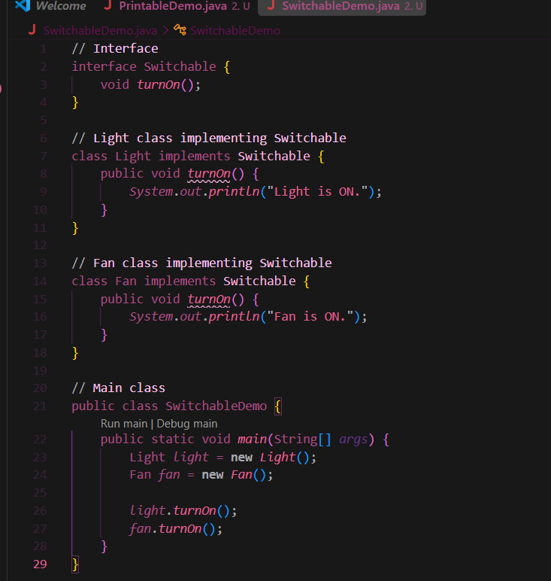
Output:
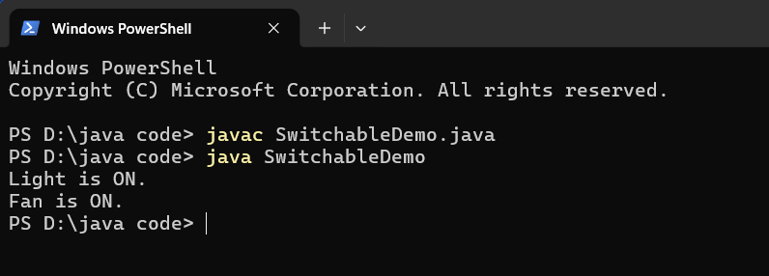

Conclusion:

This experiment demonstrated the implementation of interfaces in Java. By creating the Printable and Switchable interfaces and implementing them in different classes, we learned how interfaces provide abstraction, code reusability, and multiple inheritance of type. Different classes were able to define their own implementations of the same methods, making the program more flexible, modular, and easier to maintain.

